If Condition Step

Objective

Use the if statement to specify a block of Java code to be executed if a condition is true.

UI

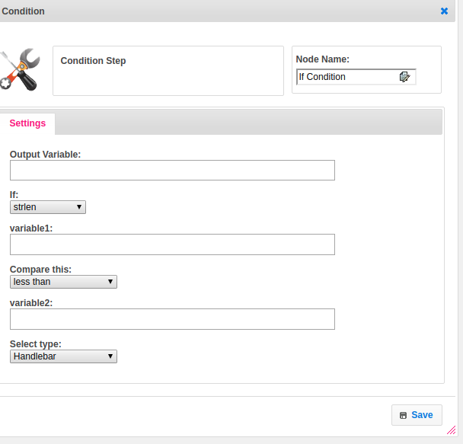

## Attributes

|  |  |
| --- | --- |
| **Attributes** | **Description** |
| **1. Output Variable** | Used to store the response of the request. |
| **2. If** | It contains two types, to compare the data.  1.value - Condition based on variable values.  2.strlen - Condition based on variable length. |
| **3. variable1** | Variable1 holds the first variable value. |
| **4. Compare This** | Comparison operators are used to comparing two values. |
| **5. variable2** | Variable2 holds the second variable value. |
| **6. Select Type** | Value_type used to set the value type.  Value types are two types.  1.hb-HandleBars  2.ftl-Freemarker Template Language. |

## Executor Description

Evaluating expression with variable1 and variable2 by comparing with compare operator. Check the variable1 and variable2 contains data or not. Compare the variable1 and variable2 by using comparator operator. Finally, return the response to step.

## Resource

Please refer the following link to get more information.

<https://www.javatpoint.com/java-if-else>